**Content Based Image Retrieval**

*– Kruthika Gangaraju and Sriram Kodeeswaran*

***Description:***

Content Based Image Retrieval (CBIR) is a popular approach for image retrieval and is widely used in many applications such as image search engines, medical image databases, and digital libraries. The main idea behind CBIR is to compare the features of the target image with the features of the images in the database and retrieve the ones that are most similar.

***Task 1 - Baseline Matching:***

This program takes a target image and compares the color values of pixels in a 9x9 square centered at the center of the target image with the color values of pixels in a similar 9x9 square centered at the center of each image in a database. The comparison is performed by calculating the sum of squared differences between the color values of each pixel in the two squares and using the result as a measure of similarity. The program outputs the filenames of the top 3 closest images to the target image based on this similarity measure.

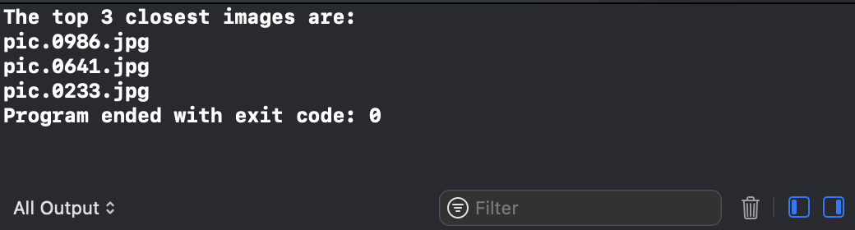

*Output*

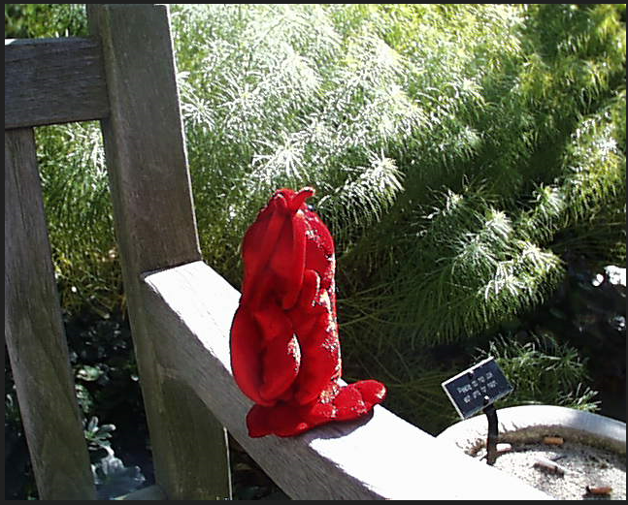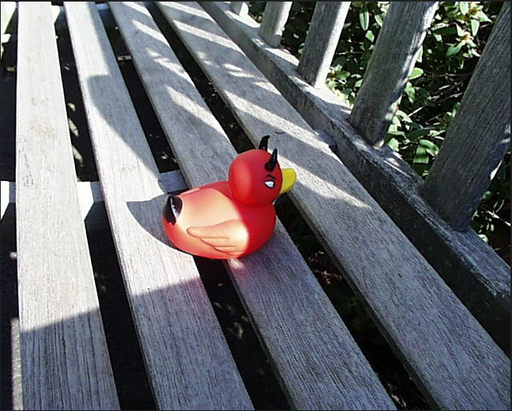

*Target Image(pic.1016.jpg)*  *Match 1(pic.0986.jpg)*

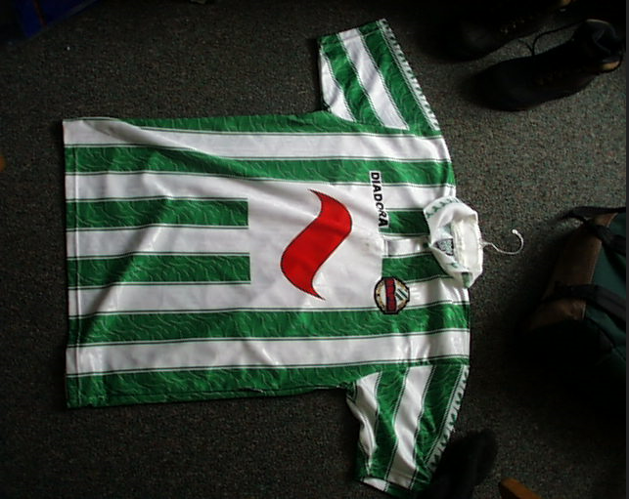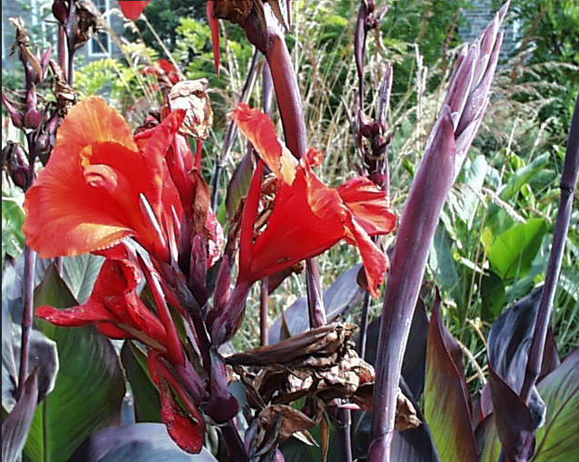

*Match 2(pic.0641.jpg)*   *Match 3(pic.0233.jpg)*

***Task 2 - Histogram Matching:***

Histogram matching is a process of transforming the intensities of one image to match the intensities of another image. The code takes two images as inputs, the reference image and the source image, and creates a mapping between the intensities of the reference image and the source image. The mapping is then used to transform the source image so that its histogram matches the histogram of the reference image.

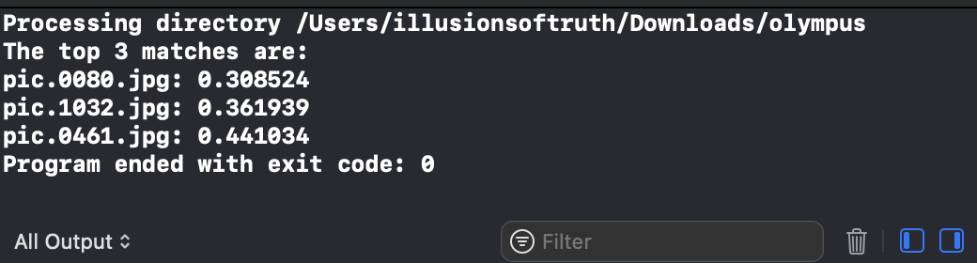

*Output*

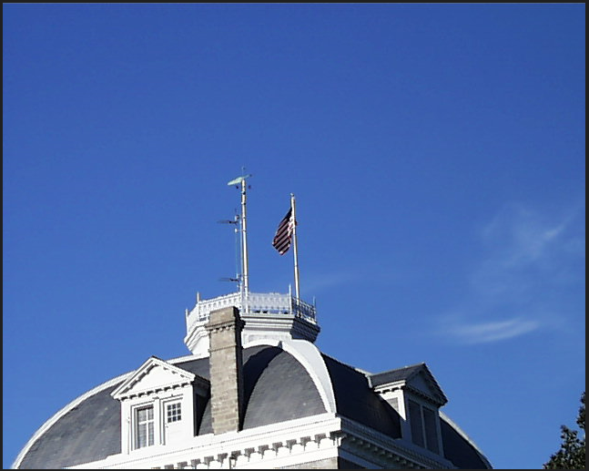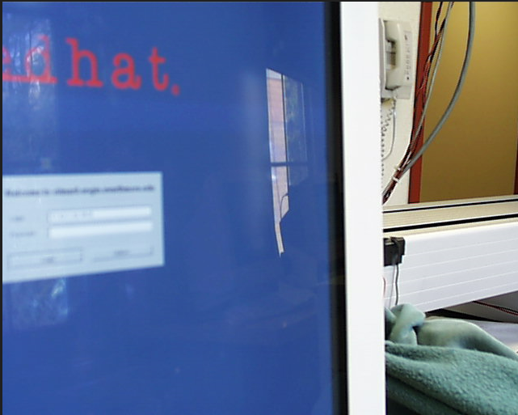

*Target Image(pic.0164.jpg)*  *Match 1(pic.0080.jpg)*

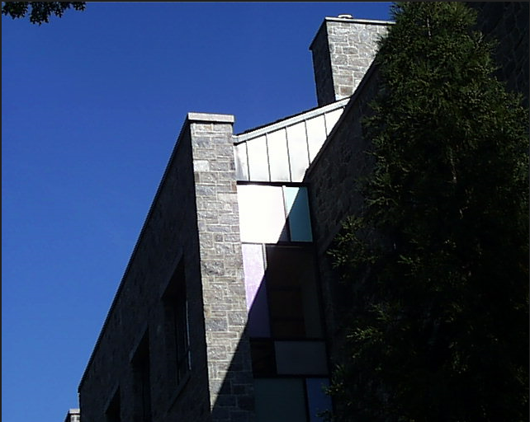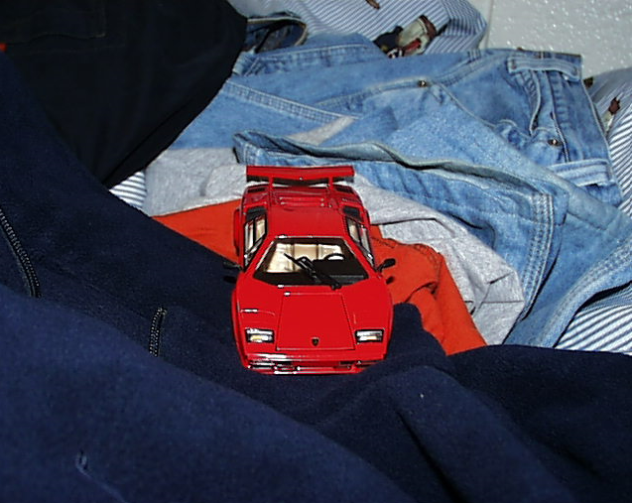

*Match 2(pic.1032.jpg) Match 3(pic.0461.jpg)*

***Task 3 - Multi Histogram Matching:***

Following the same logic for histogram matching but now using two different histograms, one for the upper part of the image and one for the lower part of the image, we got the results for image pic. .jpg as:

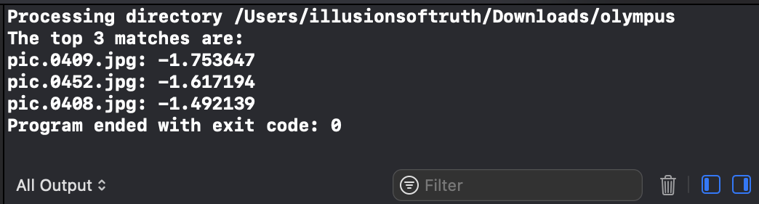

*Output*

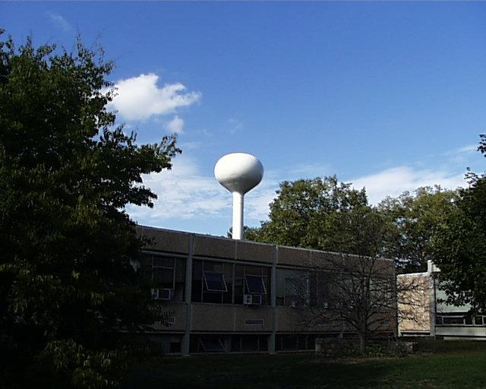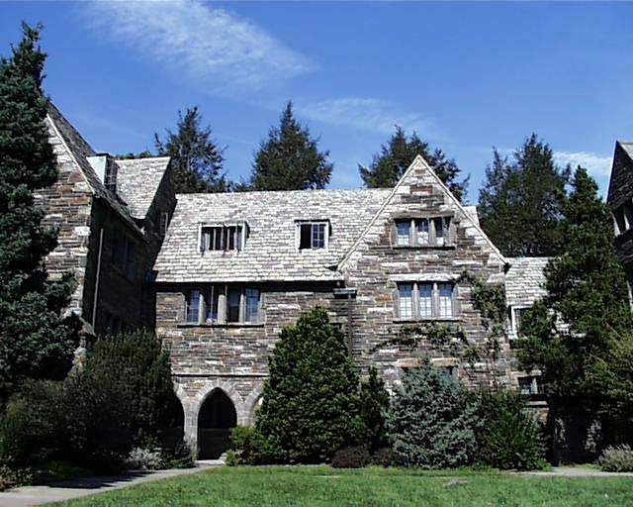

*Target Image(pic.0274.jpg) Match 1(pic.0409.jpg)*

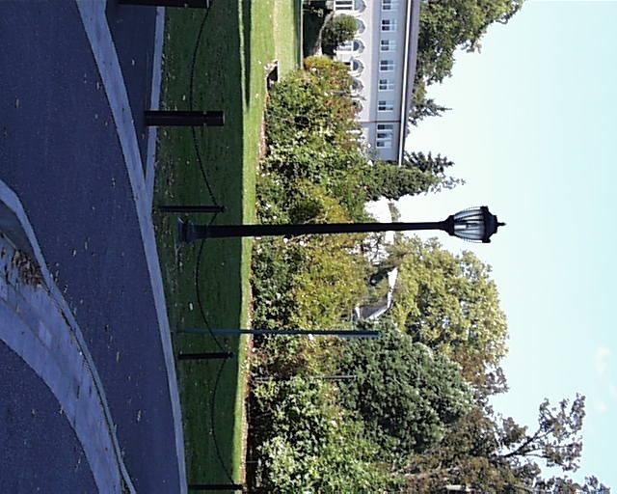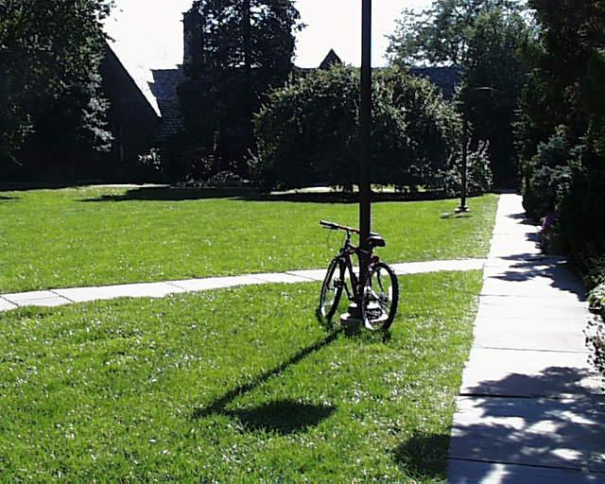

*Match 2(pic.0409.jpg) Match 3(pic.0408.jpg)*

***Task 4 - Texture and Color Matching:***

It first applies a Sobel filter on an input image in both x and y directions using the sobel_x and sobel_y functions. The Sobel filter is used to calculate the gradient of an image and highlight edges. Then, it calculates the histogram of the gradient values in the red, green, and blue color channels. The histogram is used to summarize the color information of an image. We can see from the output that the colors and textures for the output images are very close to the target image.

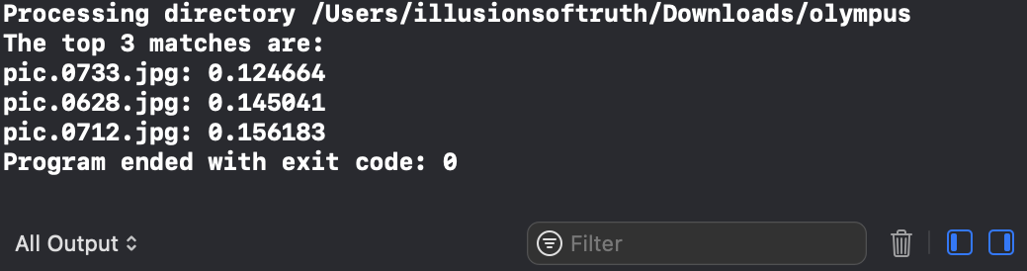

*Output*

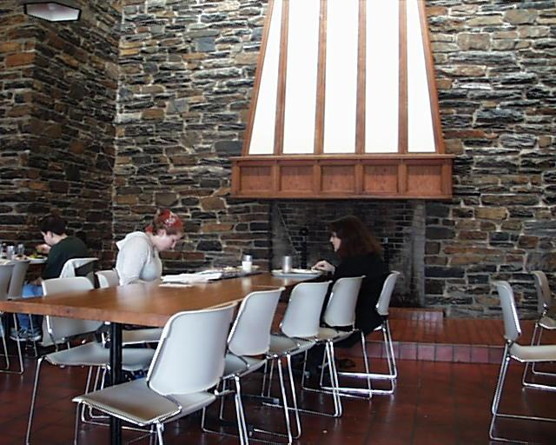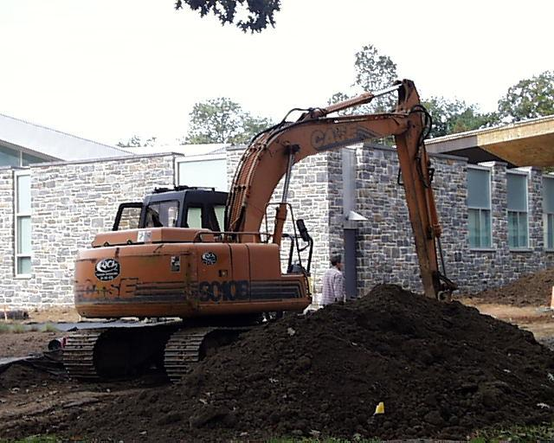

*Target Image(pic.0535.jpg) Match 1(pic.0733.jpg)*

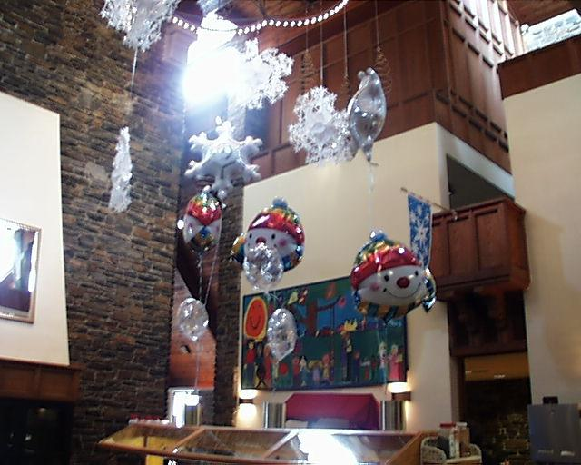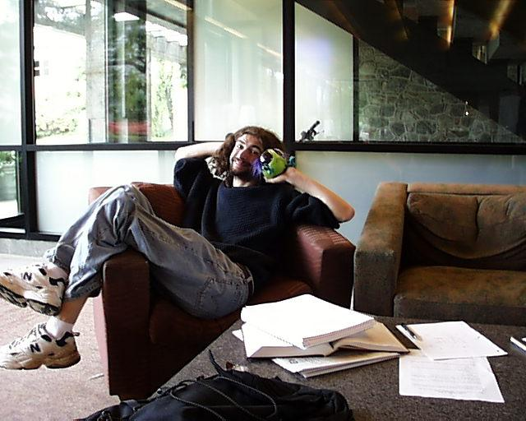

*Match 2(pic.0733.jpg) Match 3(pic.0712.jpg)*

After comparing results using normal histograms and texture and color histograms, we can notice one thing. Using a 2D or 3D histogram returns an image which has very similar features in the entire image whereas for a texture histogram we can see that the output images have similar color schemes and textures but do not necessarily resemble each other.

***Task 5 - Custom Matching:***

For this task, we decided to do template matching. For this we used the OpenCV function matchTemplate() which inputs a template (or our target image) and matches with images in the database using any defined methods. We used the TM_SQDIFF_NORMED method for distance metric. Then we calculated the minimum and maximum values for the distance metric and sorted them in ascending order. This gave us a set of images of which most of them were similar to the target image.

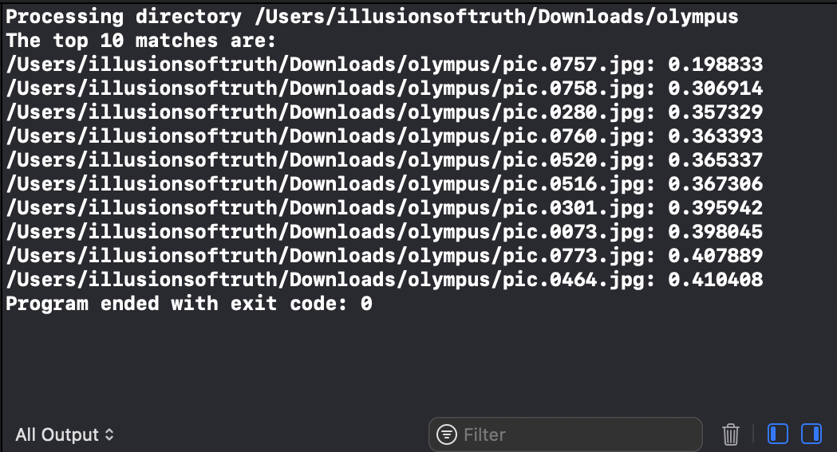

*Output*

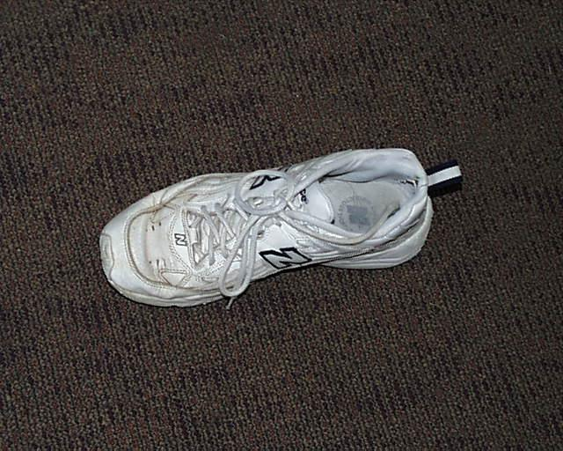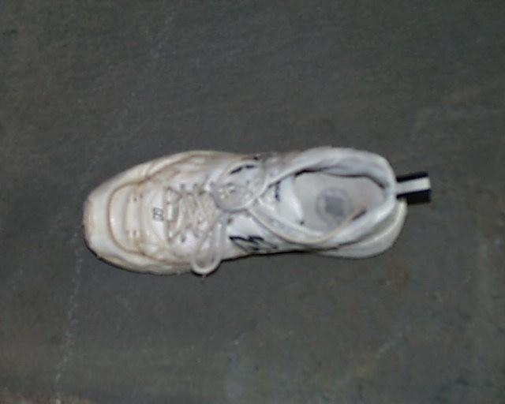

*Target Image(pic.0756.jpg) Match 1(pic.0757.jpg)*

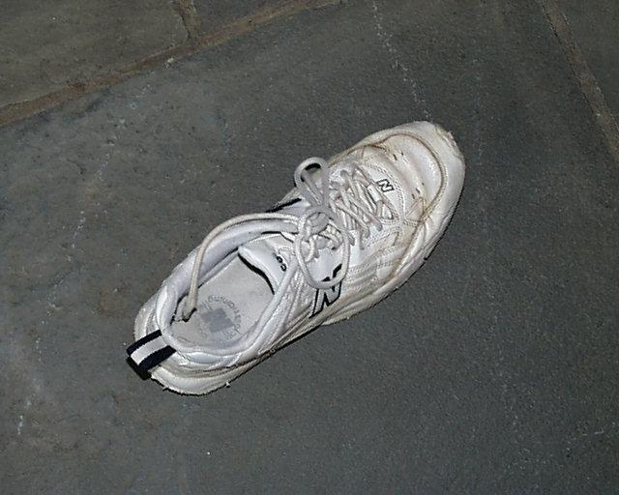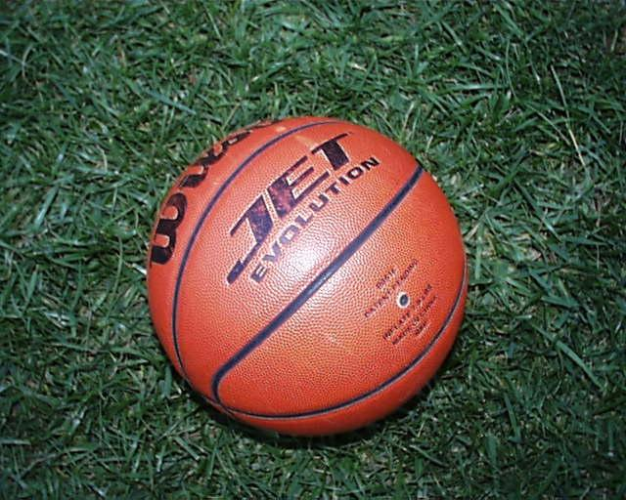

*Match 2(pic.0758.jpg) Match 3(pic.0280.jpg)*

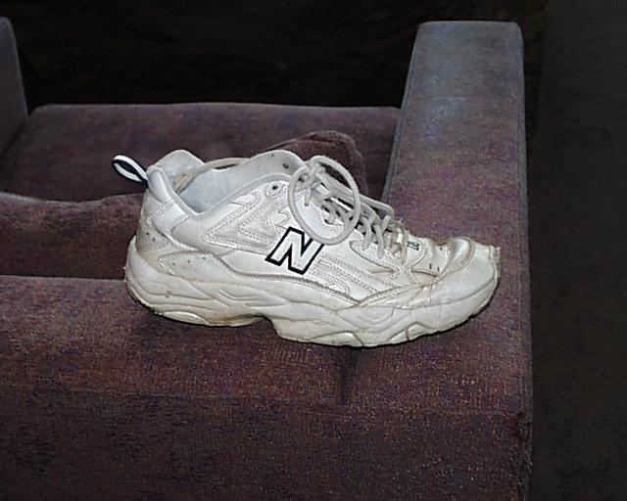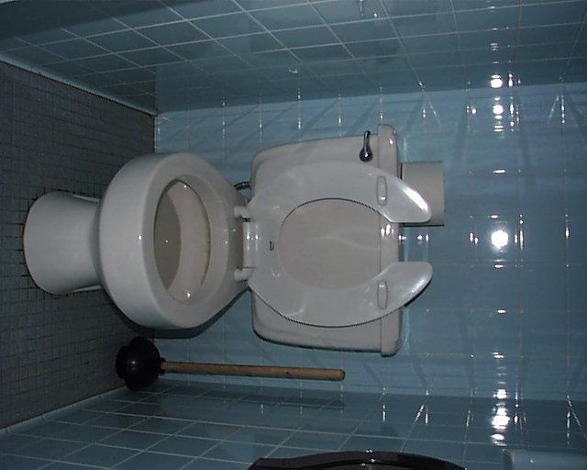

*Match 4(pic.0760.jpg) Match 5(pic.0520.jpg)*

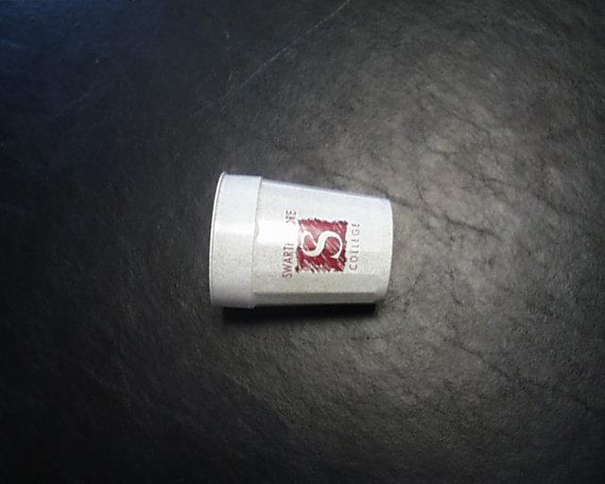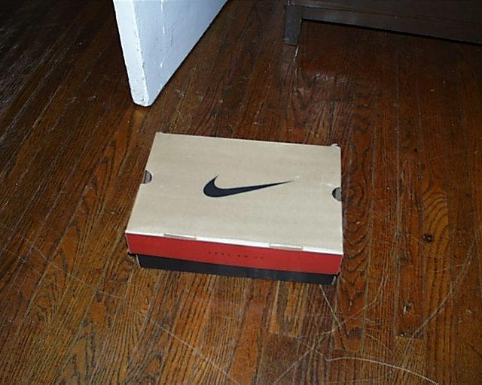

*Match 6(pic.0516.jpg) Match 7(pic.0301.jpg)*

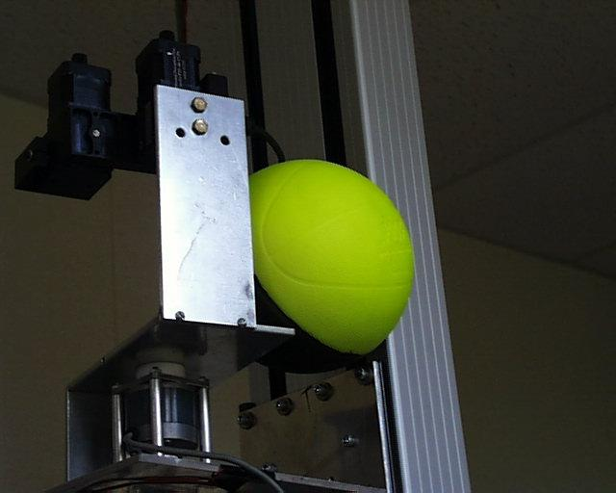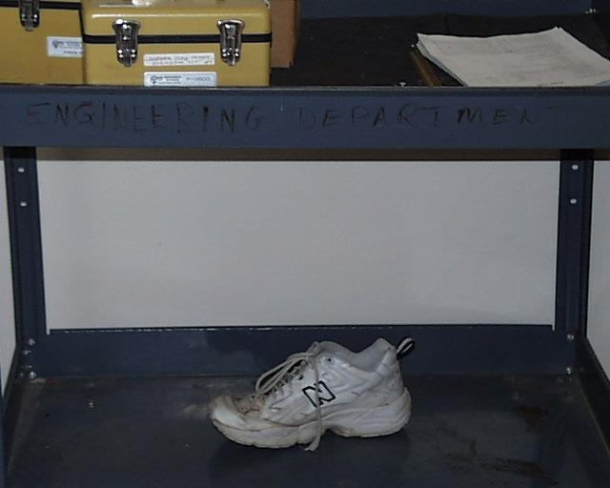

*Match 8(pic.0073.jpg) Match 9(pic.0773.jpg)*

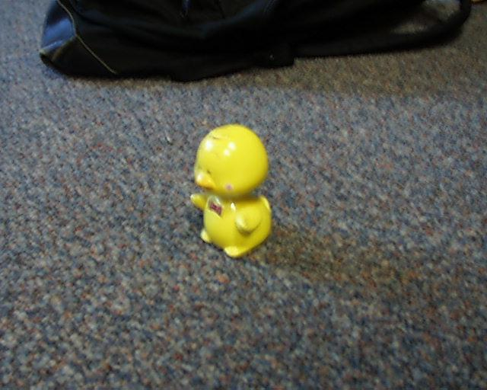

*Match 10(pic.0464.jpg)*

***Extensions:***

*– Histograms of Gabor filter responses*

It applies a Gabor filter to an image and calculates histograms of the filtered image and original image. The filtered image is generated by applying a 2D convolution of the input image with a Gabor filter. The filter is generated using the parameters size, sigma, theta, lambda, and gamma. The texture of the image is represented by the histogram of the filtered image, while the color is represented by the histogram of the original image. Both histograms are stored in separate arrays, which are concatenated and returned as the final feature vector.

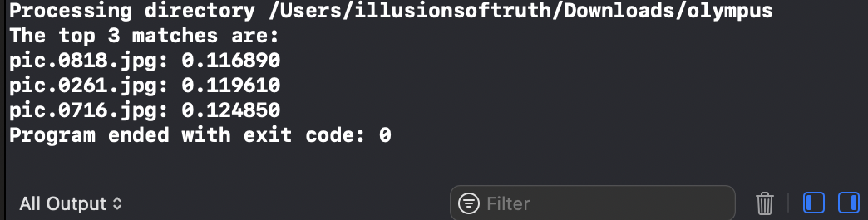

*Output*

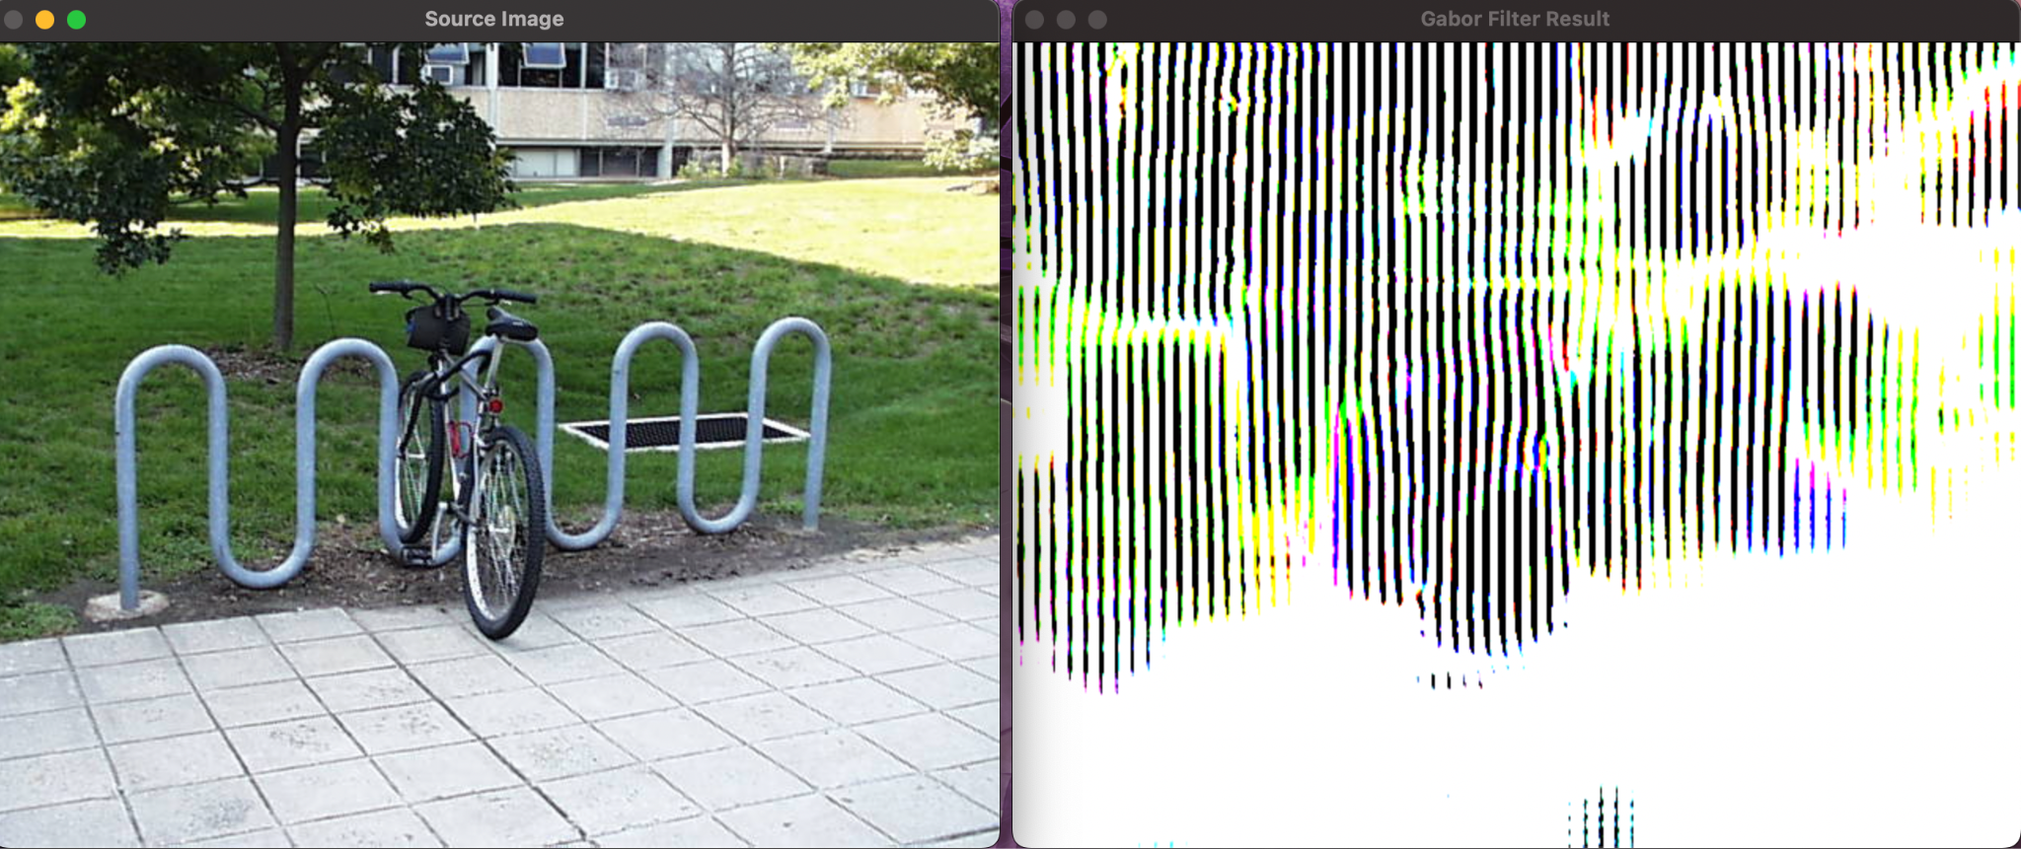

*Target Image(pic.0210.jpg)*

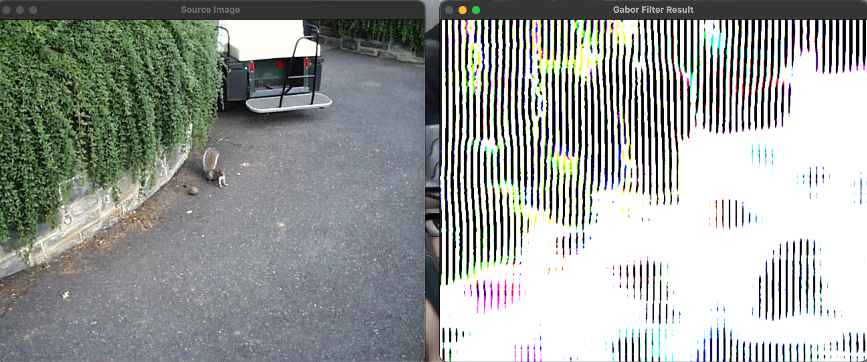

*Match 1(pic.0818.jpg)*

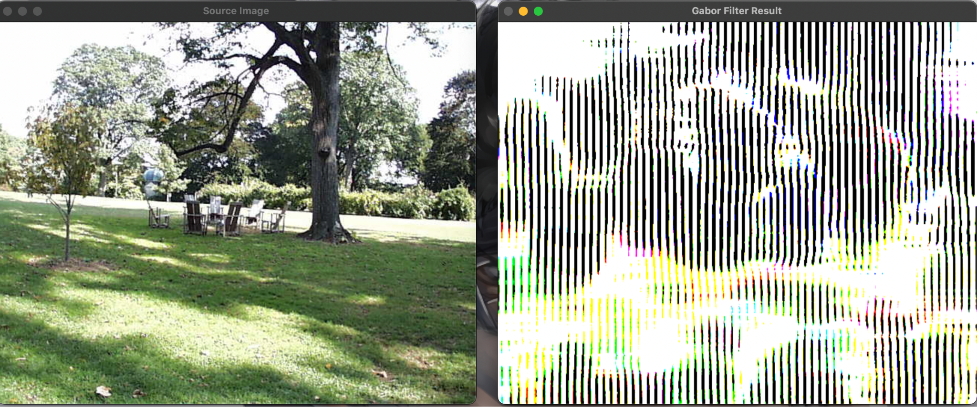

*Match 2(pic.0261.jpg)*

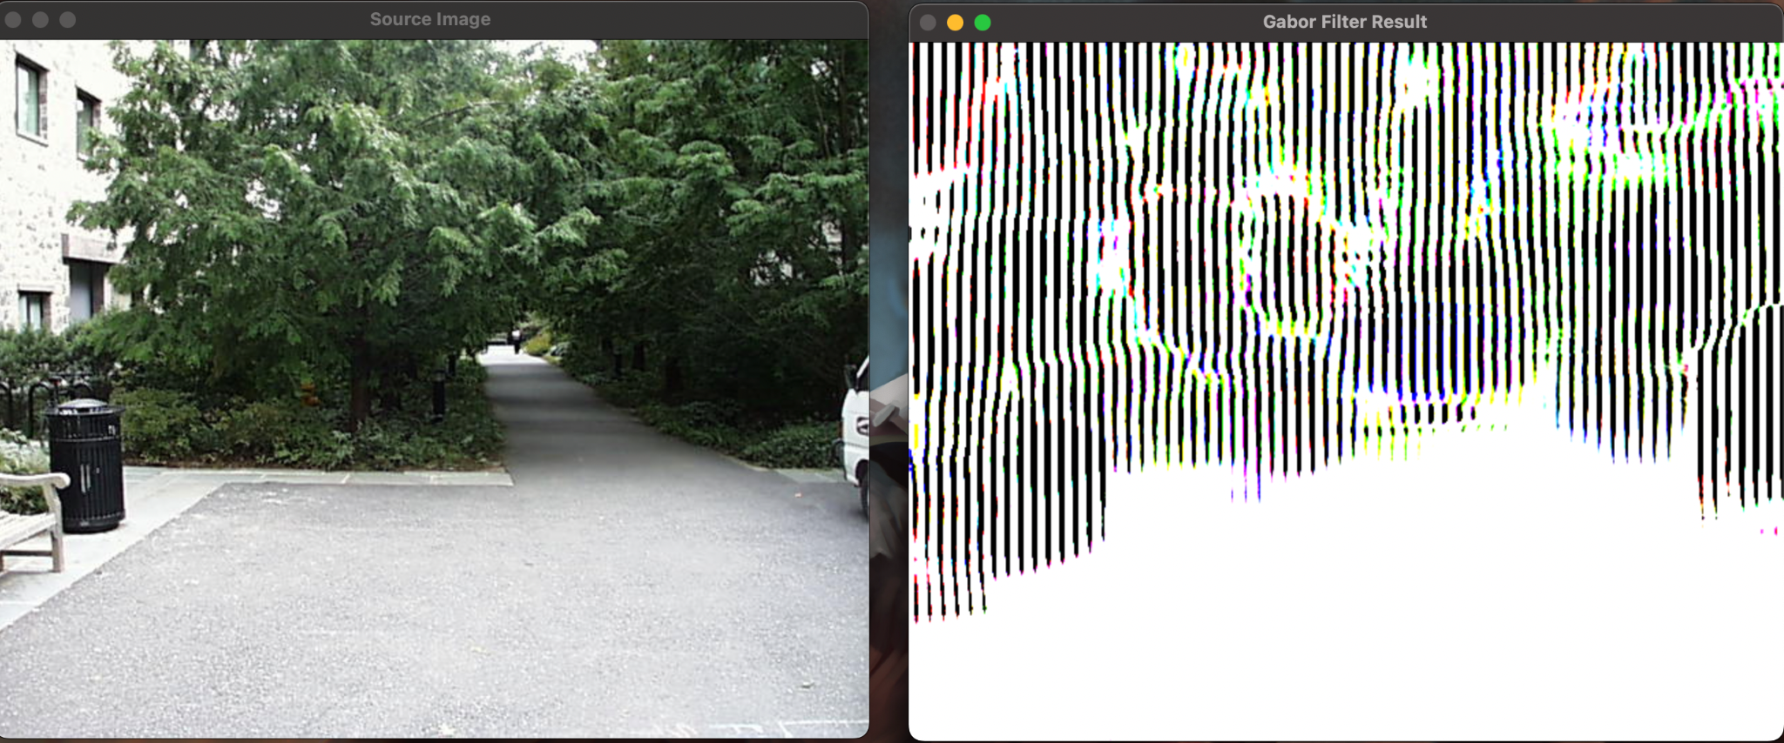

*Match 3(pic.716.jpg)*

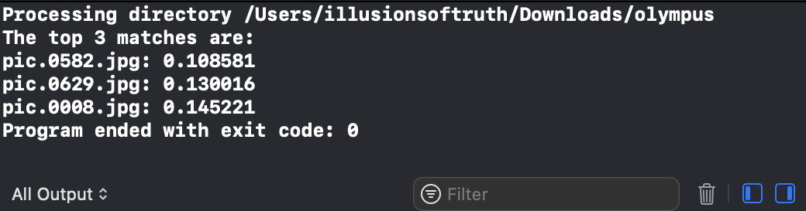

*Output*

***Acknowledgements:***

Firstly we would like to thank Prof. Bruce Maxwell for introducing this topic and always being available to clarify any doubts we encountered. Next we would like to thank the TAs, David Anderson, for helping us out understand the problems and helping us with the errors we kept getting. Finally we would like to mention a few sites that helped us understand few OpenCV and C++ functions:

* [OpenCV: Template Matching](https://docs.opencv.org/3.4/d4/dc6/tutorial_py_template_matching.html#:~:text=Template%20Matching%20is%20a%20method%20for%20searching%20and,patch%20of%20input%20image%20under%20the%20template%20image.)
* [What is image Normalization?. Linear Normalization is the process… | by Shoaib Rashid | Medium](https://medium.com/@shoaibrashid/what-is-image-normalization-d8305bf328c0)
* [Color histogram - Wikipedia](https://en.wikipedia.org/wiki/Color_histogram)
* [How can I normalize histogram? - OpenCV Q&A Forum](https://answers.opencv.org/question/14598/how-can-i-normalize-histogram/)
* <https://www.geeksforgeeks.org/sort-vector-of-pairs-in-ascending-order-in-c/?ref=rp>
* <https://www.geeksforgeeks.org/structures-in-cpp/>
* <https://mathworld.wolfram.com/L2-Norm.html>

***Reflection:***

Learning new concepts in OpenCV is always challenging as well as useful. Image Retrieval is one of the most useful concepts of OpenCV and through this assignment we firstly studied many different methods of retrieving similar images. By constructing the functions from scratch, it made us understand the scrutinies of each type of matching and how it actually affects the output. Lastly, for developing a custom feature, we had many concepts in mind and tried many things but finally found template matching to work satisfactorily. Although we didn't succeed in other methods, we would definitely like to have a discussion with Prof. Maxwell to make these methods work too.